Aim:

To demonstrate Database as a Service (DaaS) by creating and configuring a database instance using Microsoft Azure.

Procedure:

1. Log in to Azure Portal (https://portal.azure.com).

2. Create a new Resource Group (e.g., db-demo-rg).

3. Search for Azure SQL Database → + Create.

4. Under Database details:

* Database name: studentdb
* Server: create new SQL server → give a unique server name, admin username/password.
* Compute + Storage: choose Basic (demo).

5. Configure Networking:

* Allow Azure services and your IP address to access.

6. Click Review + Create → Create.

7. Once deployed, go to the SQL database → copy Connection string.

8. Connect using Azure Data Studio or SQL Server Management Studio (SSMS) with the server name, username, and password.

9. Create a test table and insert sample records to verify the database is working.

SQL Database overview:

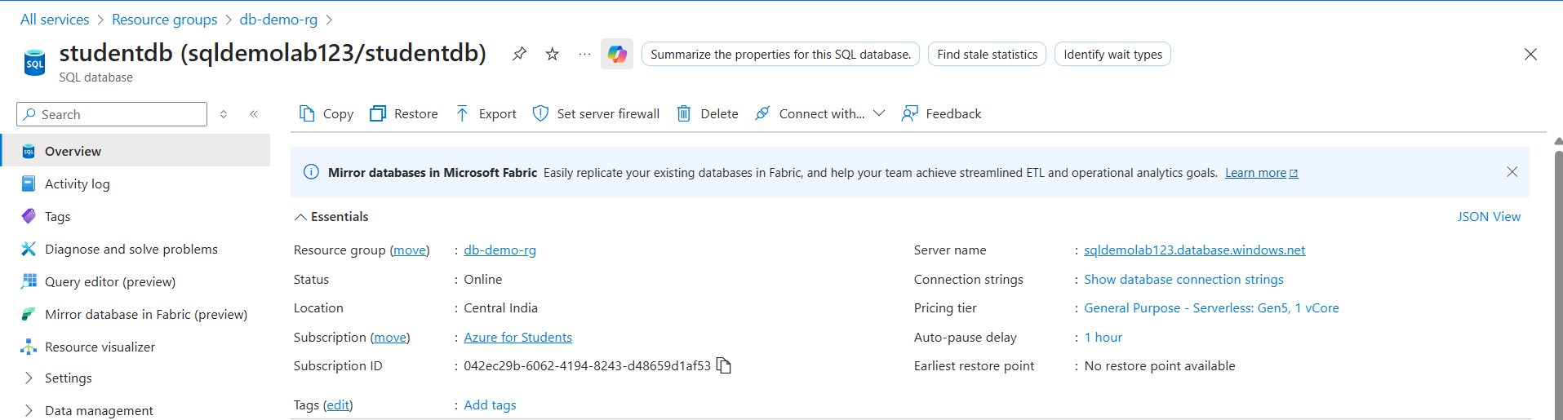

Query Editor:

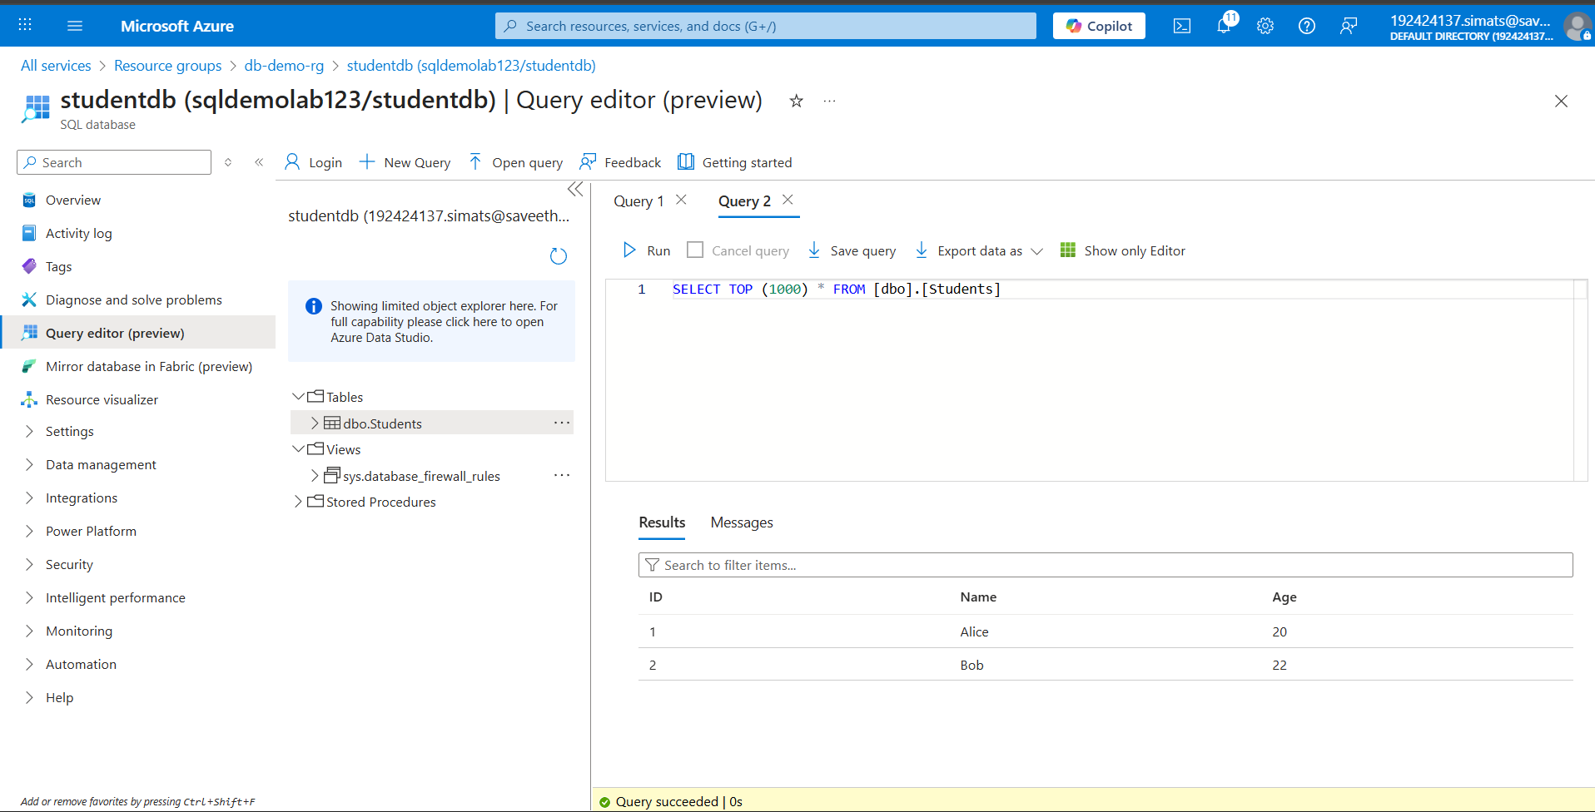

Result:

A database service was successfully created and configured in Azure.  
The database was tested with sample records and accessed via client tools, demonstrating Database as a Service (DaaS) functionality.